 



Database Programming with SQL

* 1. : Relational Database Technology Practice Activities

# Objectives

* + - Define and give an example of a relational database
    - Identify table-key terms, including row, column, field, primary key, and foreign key
    - Relate the importance of databases to everyday life

# Vocabulary

Identify the vocabulary word for each definition below.

|  |  |
| --- | --- |
| row | An entry in a table, consisting of values for each appropriate column. |
| **primary key** | The set of mandatory columns within a table that is used to enforce uniqueness of rows, and that is normally the most frequent means by which rows are accessed. |
| **Table** | An arrangement of data in rows and columns. |
| **foreign key** | A column or set of columns that refers to a primary key in the same table or another table. |
| **relational dB** | Collections of objects or relations, set of operators to act on those relations, and data integrity for accuracy and consistency |
| **field** | Intersection of a row and column |
| **data manipulation language** | Used to modify the table data by entering, changing, or removing rows |
| **data definition language** | Creates, changes, and removes data structures from the database |
| **transaction control language** | Used to manage the changes made by DML statements |
| **data control language** | Used to give or remove access rights to the database and the structures within it |

# Try It / Solve It

1. The Global Fast Foods database consists of how many tables? 9 tables

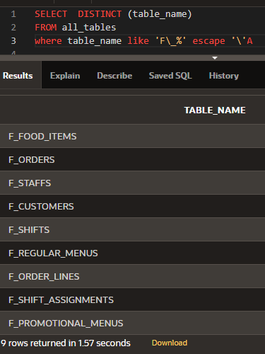

1. How is the F_SHIFTS table related to the F_STAFFS table? Через **F_SHIFT_ASSIGNMENTS.**

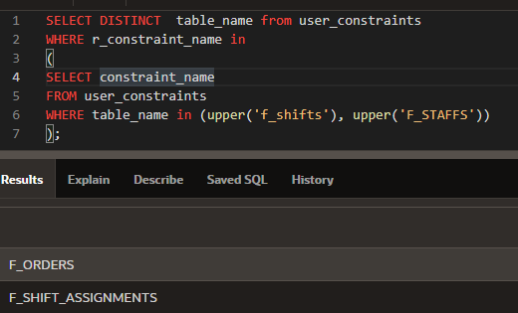

1. What are the names of the columns in the F_CUSTOMERS table?

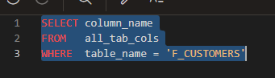

|  |
| --- |
| ID |
| FIRST_NAME |
| LAST_NAME |
| ADDRESS |
| CITY |
| STATE |
| ZIP |
| PHONE_NUMBER |

1. How many rows of data have been entered in the F_PROMOTIONAL_MENUS table?

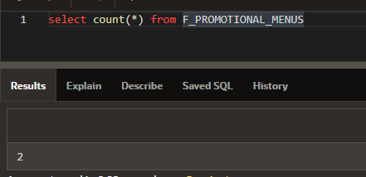

2 rows

1. In the F_FOOD_ITEMS table, column is a foreign-key column. What table and column is this key referencing?

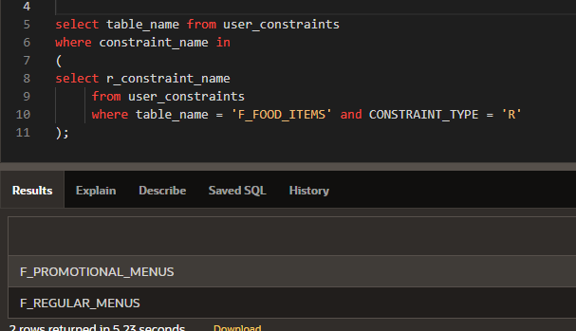

**«REGULAR_CODE» на «CODE» в «F_REGULAR_MENUS»**

**"PROMO_CODE" на "CODE" в "F_PROMOTIONAL_MENUS"**

1. List the primary key to foreign key relationships required to go from the F_SHIFTS table to the F_REGULAR_MENUS table.

F_SFT_CODE_PK -> F_SAT_CODE_FK

F_SAT_ID_FK -> F_STF_ID_PK

F_STF_ID_PK -> F_ODR_STAFF_ID_FK

F_ODR_ORDER_NUMBER_PK -> F_OLE_ORDER_NUMBER_FK

F_OLE_FOOD_ITEM_NUMBER_FK -> F_FIM_FOOD_ITEM_NUMBER_PK

F_FIM_REGULAR_CODE_FK -> F_RMU_CODE_PK

1. Which table(s) contains null values?

F_FOOD_ITEMS, F_STAFF

